Guru ecommerce project

**Day 1: Project Kickoff! Ecommerce**

Here is a link to the AUT - [http://live.guru99.com/index.php/](http://clicks.aweber.com/y/ct/?l=Oh473&m=3_dx7v7KqxQLjy9&b=XPmpPqdXY5pBIHt5A22KNg)

The following test case needs to be automated -

|  |
| --- |
|  |

The client has requested you to use WebDriver (Firefox Driver) for the project. Go ahead and record the script in Webdriver.

****************************************************************************************

**Day 2: Next Script!**

The client wants you to verify the following scenario

**“Verify that cost of product in list page and details page are equal”.**

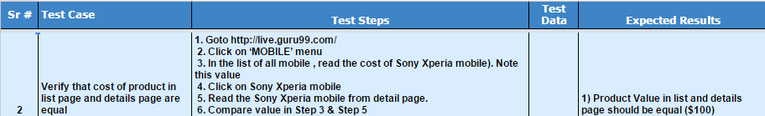

Go ahead and automate this -

|  |
| --- |
|  |

Go ahead and code the script.

****************************************************************************************

**Day 3: Error Verification**

The client wants to automate the scenario

**“Verify that you cannot add more product in cart than the product available in store”**



